JOB AID- SMART Meter Ship file validation & provisioning

  - Consumers Energy – Enhanced Operations Rel. 4a
PJT03222.SAP.DM.JA.ZDM_ESN_Provision
09/18/2014
By Legodile Kwapa

Section 1 - Intent of transaction ZDM_ESN_PROVISION-Validate & Meter Provision in OWCE:

Update Validate & Meter Provision in OWCE –transaction code ZDM_ESN_PROVISION is required for validation of the Open Way Collection Engine (OWCE) Head End Ship files (End Point Definition File [EPDL], End Point Group File [EPGL] and the Pseudo Ship File [PSF])

The transaction is comprised of three parts:
- HE Ship File validation
- Meter Provision (Add End Point Definitions to OWCE through web service call)
- Delete Ship Files that are no longer needed

Prerequisite:
- Once the End Point Definition File [EPDL], End Point Group File [EPGL] and the Pseudo Ship File [PSF] are received from ITRON.
- The BIztalk jobs for EPDL_* and EPGL_* will move the file to SAP application server for processing.
- The PSF file must be manually moved from K:\METER\SHARE\Mfg Test Files PROD\ PROD Review to K:\METER\SHARE\Mfg Test Files PROD. The PSF file must always be processed before the 305 file. Both the PSF and 305 files are found in the K:\METER\SHARE\Mfg Test Files PROD\ PROD Review.
- A BizTalk job will pick up the files from K:\METER\SHARE\Mfg Test Files PROD and send them to the SAP application server for processing.
- The Pseudo Ship Files (PSF) must pass the validation process before the data can be staged.
- Once the Pseudo Ship File validation process is complete, the contents of the PSF will be staged in Z-table (ZTDM_PSF_STAGING).
- The ZDMENHV040 and ZDMENHV050 must have already been executed, before the ZDM_ESN_PROVISION transaction can be processed.

Section 2: Process steps:

# | Section | Step # |  | Dept. |  |  | Description | Notes
Execute transaction ZDM_ESN_PROVISION  To validate:  - EPDL  - EPGL  - PSF  To Provision Meters  - AddMeterDefinitions to OWCE |  | 1 | MTC |  |  | Enter transaction ZDM_ESN_PROVISION and press enter
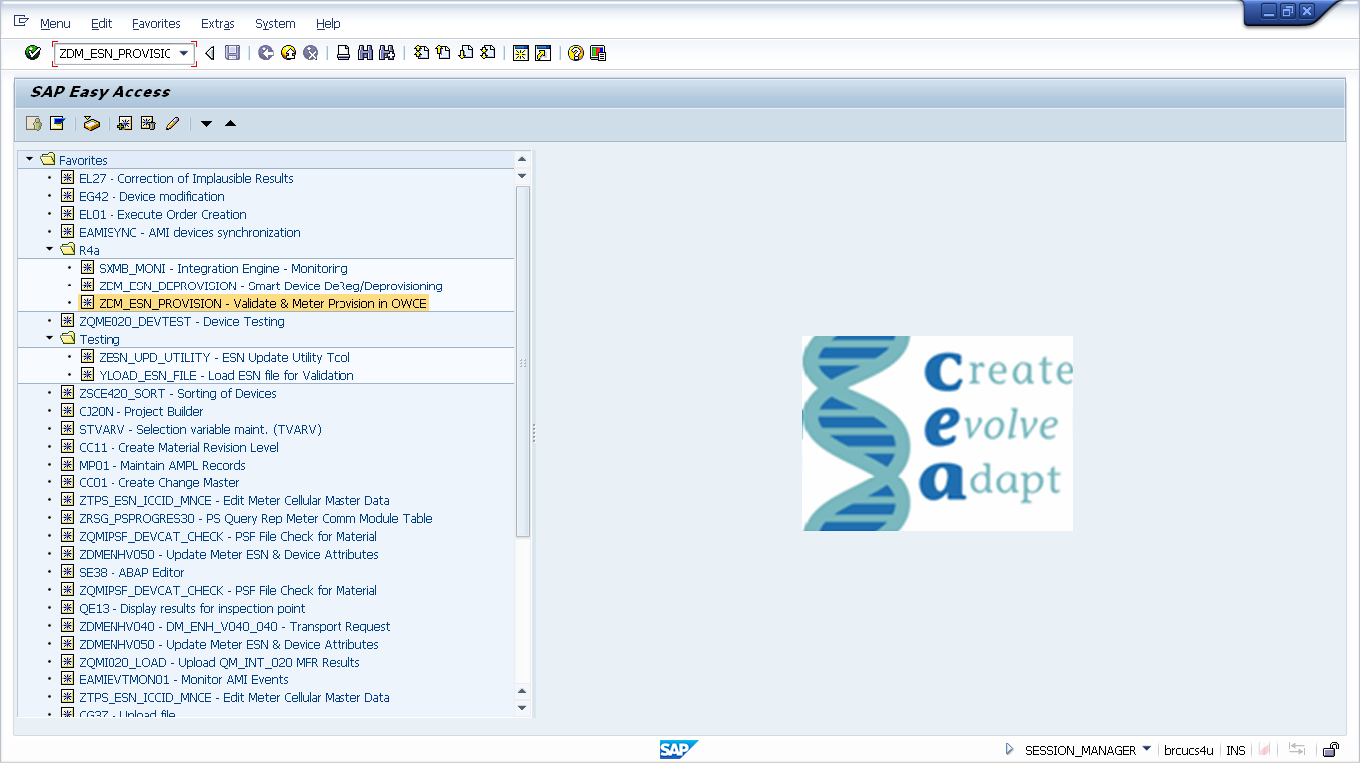

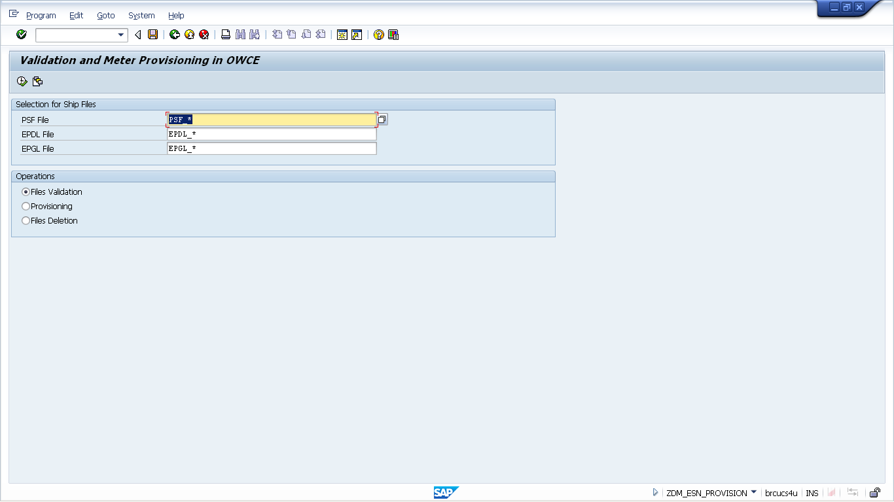

 |  | 1a | MTC |  | Select the appropriate PSF File |  |  | Selected files should belong to the same Purchase order line item and timestamp
 |  |  | MTC |  | Select the appropriate EPDL File |  |  | Selected files should belong to the same Purchase order line item and timestamp
 |  |  | MTC |  | Select the appropriate EPGL File |  |  | Selected files should belong to the same Purchase order line item and timestamp
 |  | 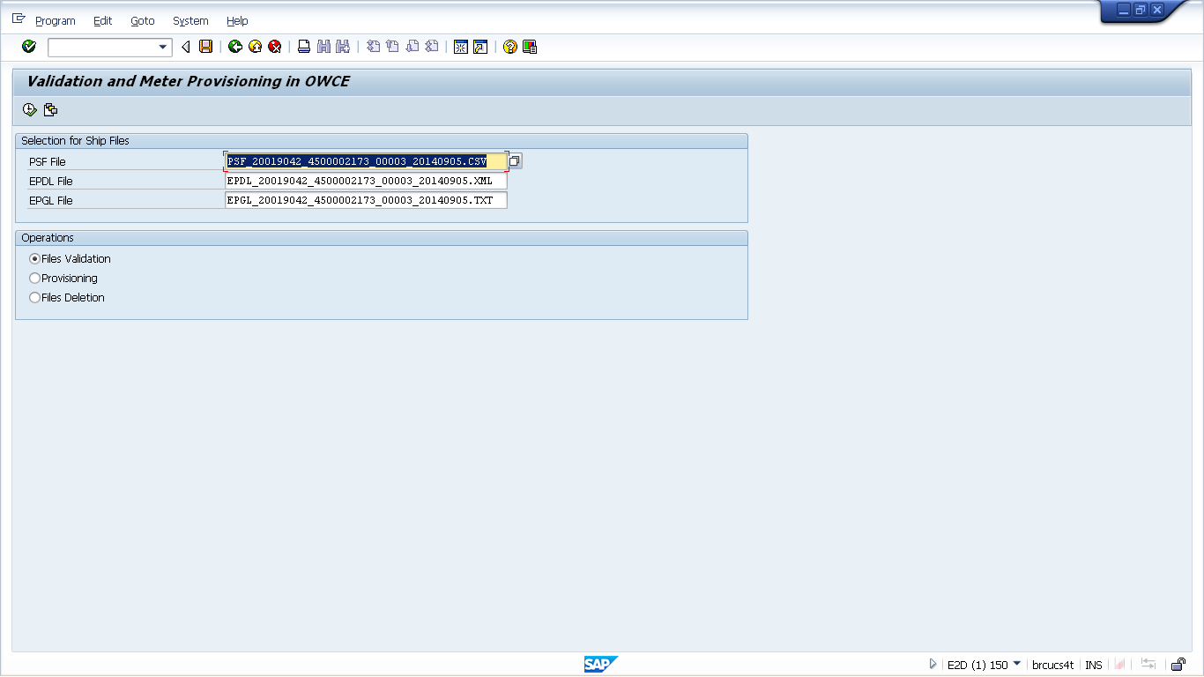
 |  | 1b | MTC |  | Under Operation select the option for Files Validation
 |  | 
 |  | 1c | MTC |  | Click on the execution icon (short-cut: F8). |  |  | Click “Yes” on the warning dialogue messages, if you wish to execute validation.
 |  | 
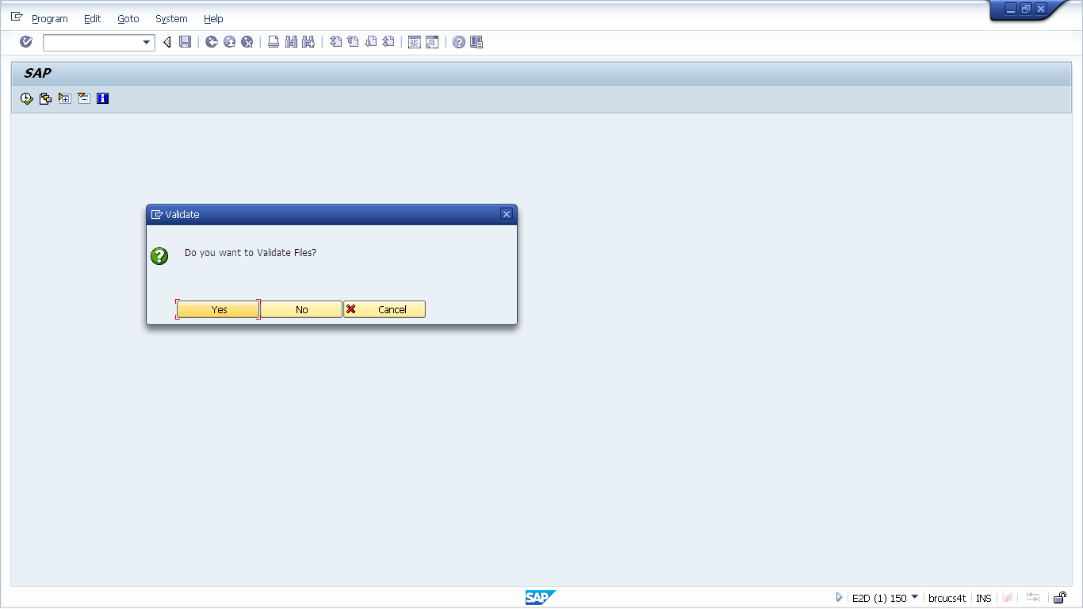

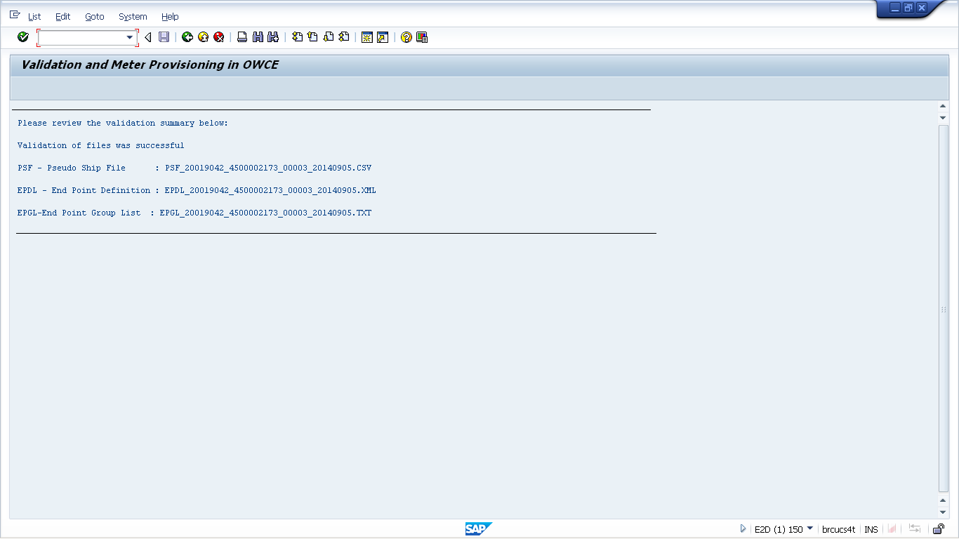

Files were successfully validated.

Validated Files will have an “X” in the valid Field

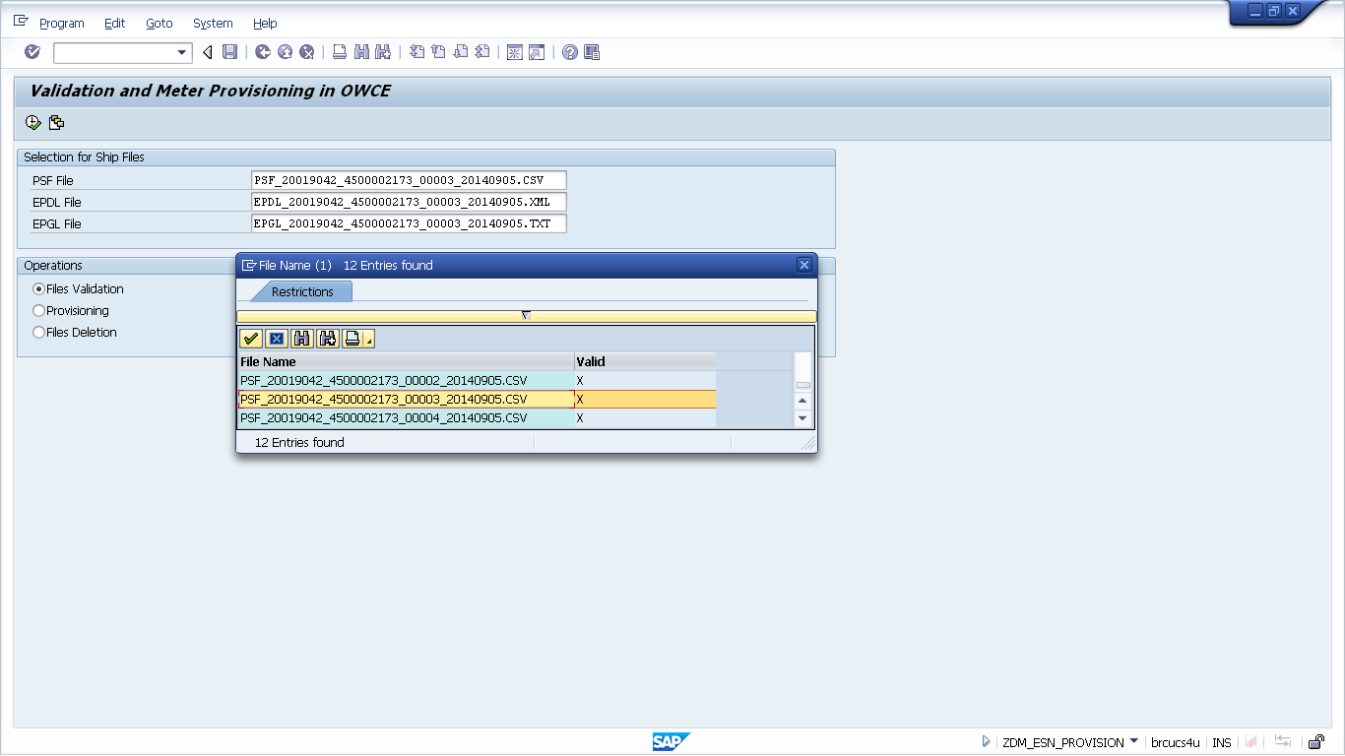

 | 2 | MTC | Provisioning of Meter | Only validated Files can be selected for Provisioning.  Please note there are two option to select the Configuration Group
 | 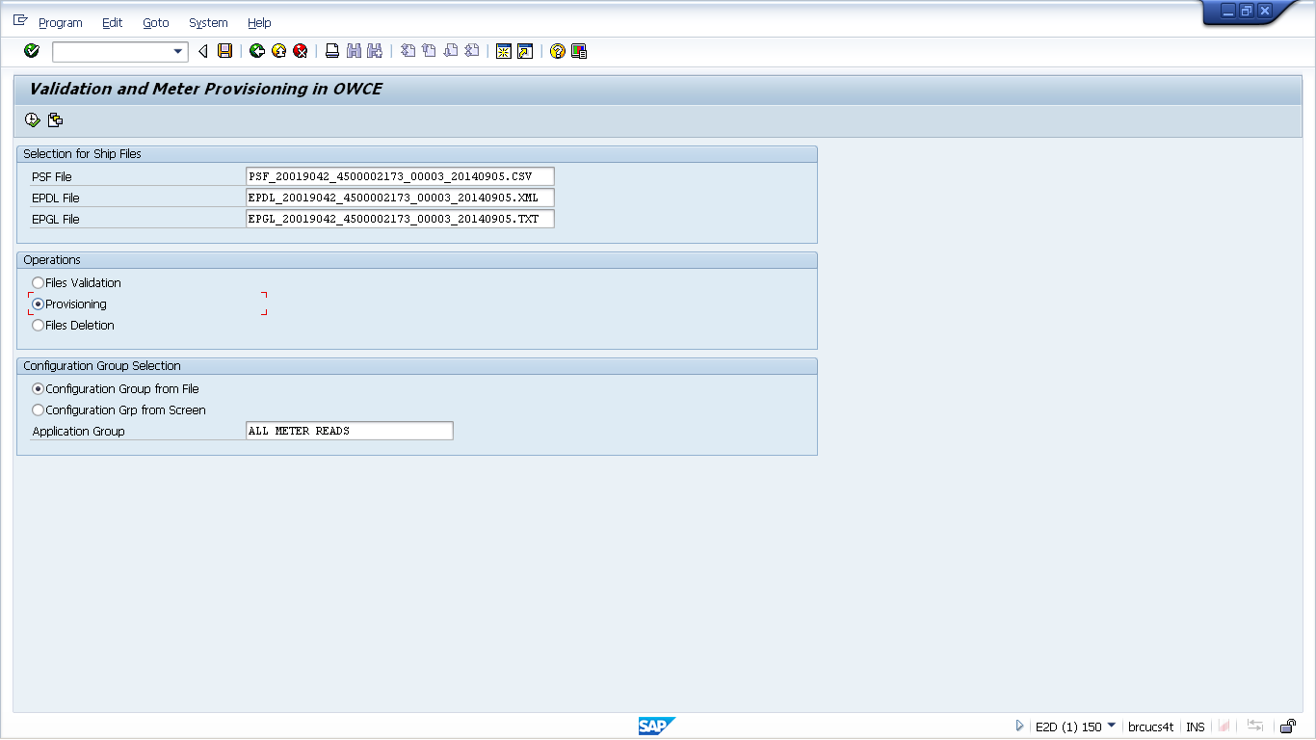
 | 2a | MTC | Configuration Group from File Option | Select all if you wish to Configuration Group entries in the PSF file.  NB: Please review PSF file to validate if meter will be installed in the correct group
 | 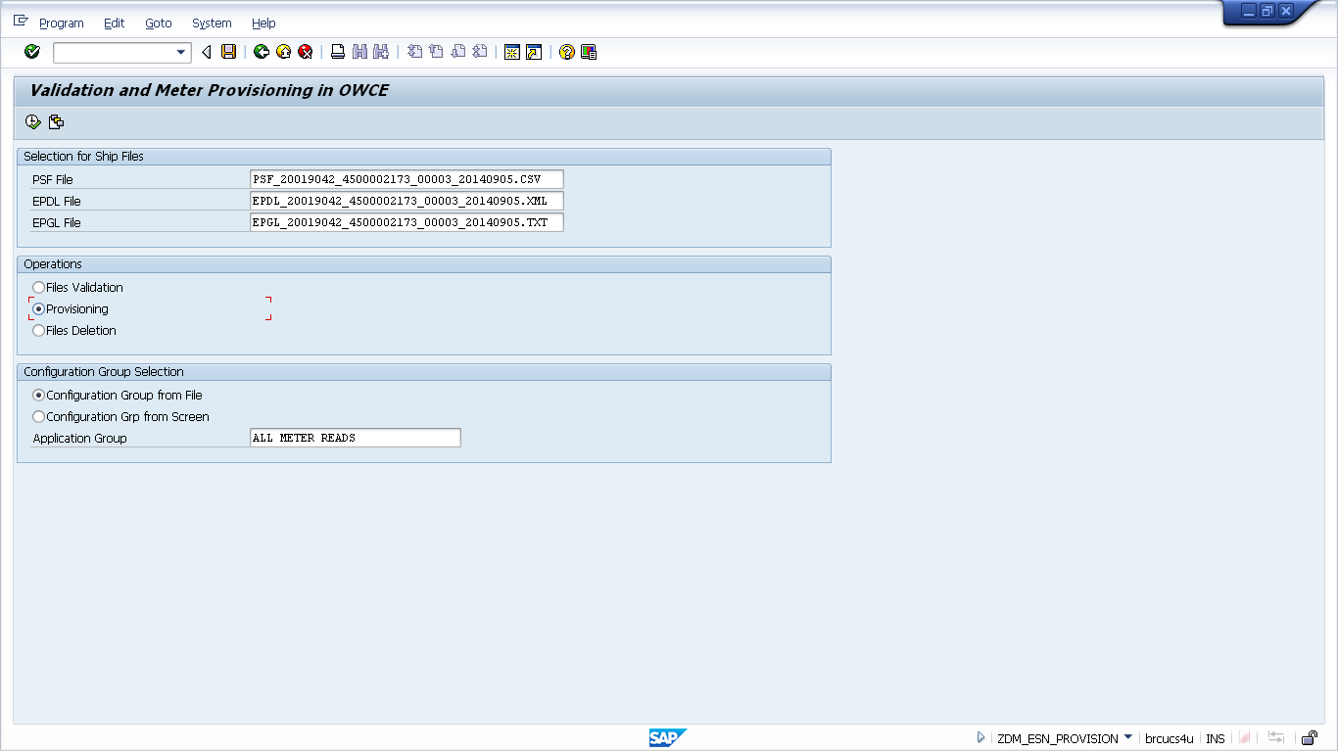
 | 2b | MTC | Configuration Group from Screen Option | Select all if you wish to specify the Configuration Group.
 | 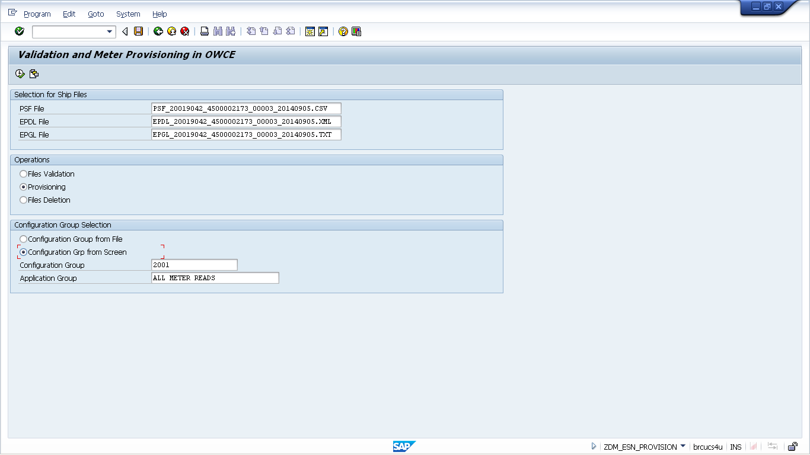
 | 2c | MTC | Only change Application Group if requested to do so by SEOC. Else run with default “ALL METER READS”. | Please note: that user has the flexibility to change both Configuration Group and Application Group to suit changing business requirements
 | 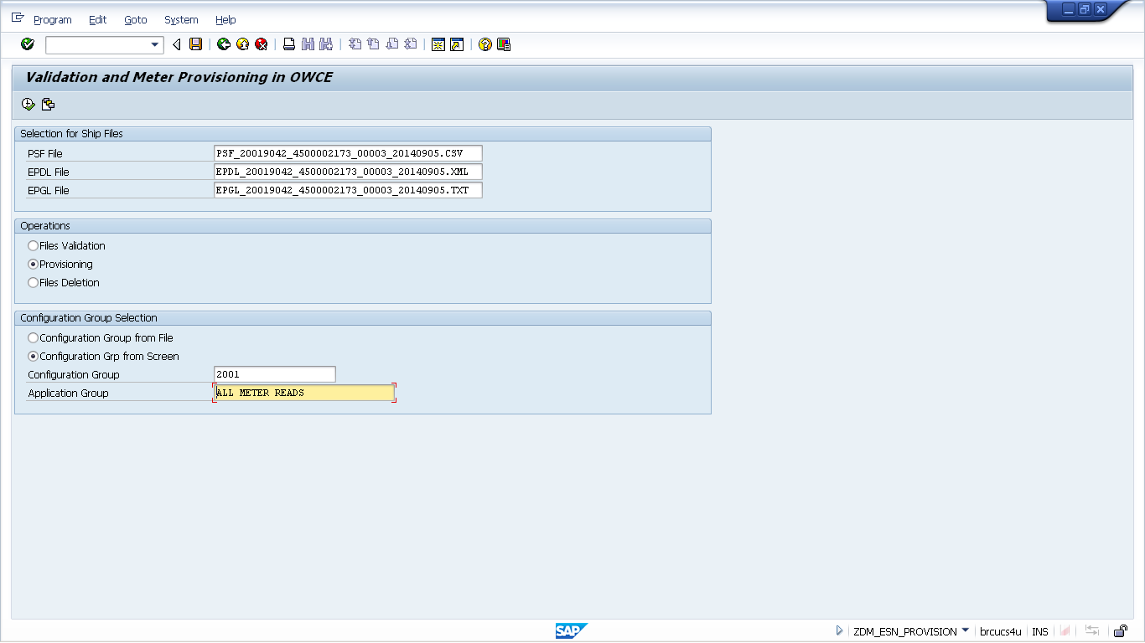
 | 2d | MTC | Click on the execution icon (short-cut: F8). | Click “Yes”” on the warning dialogue messages, if you wish to trigger web service request.


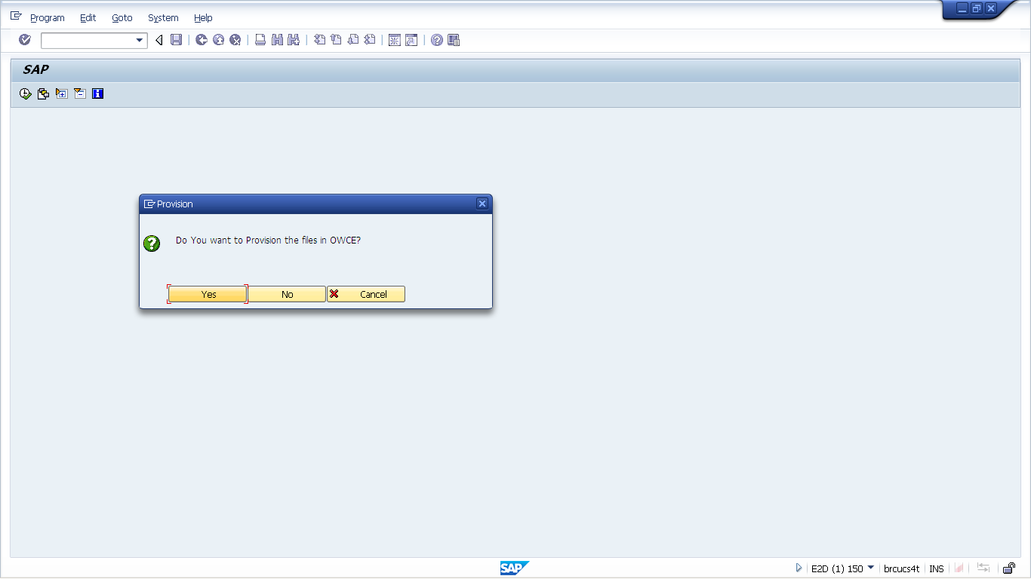

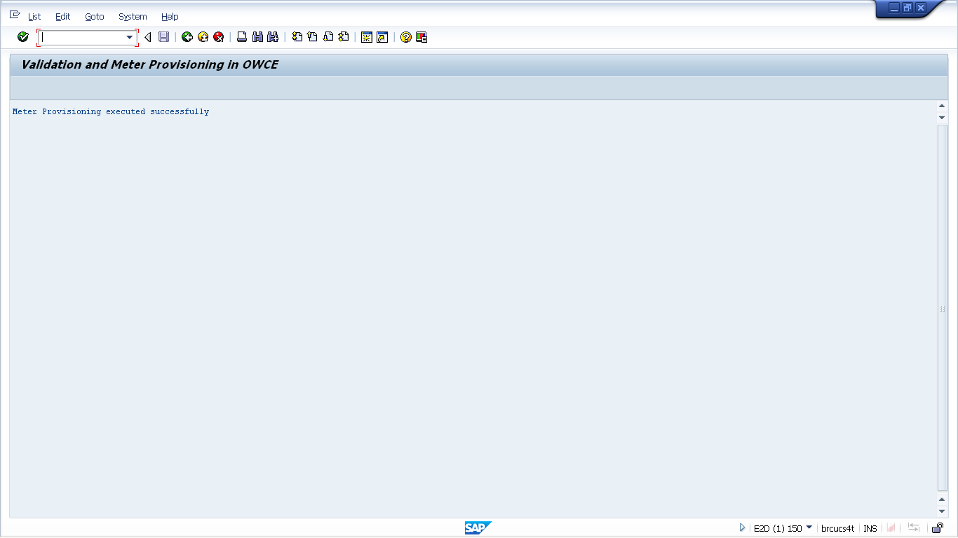

Web Service To Provision Meters was successfully triggered.

 | 2e | MTC | Confirmation Email is sent to Joint MTC-SEOC P.O. Box.

To Delete old Validated Files |  | 3 | MTC | Under Operations select option for Files Deletion
 |  | 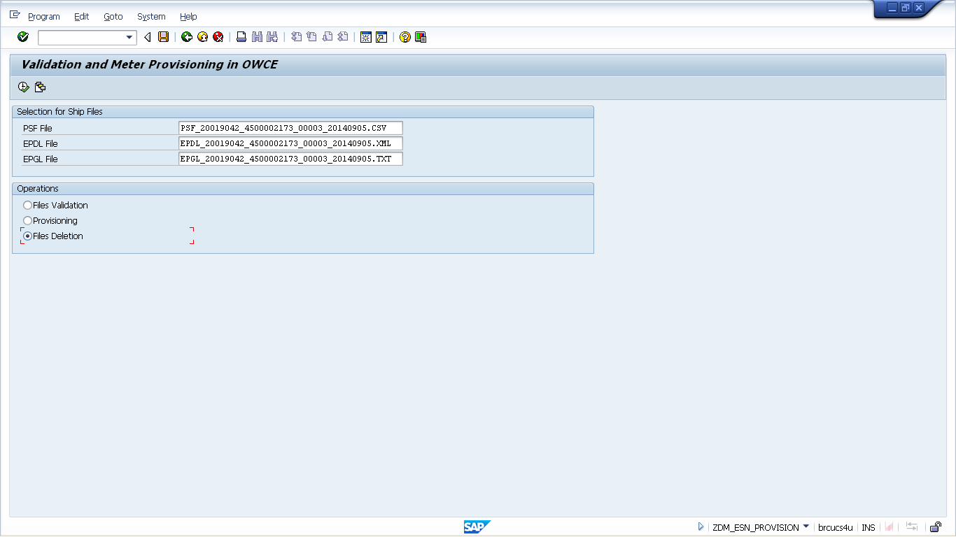
 |  | 3a | MTC | Click on the execution icon (short-cut: F8). | Click “Yes”” on the warning dialogue messages, if you wish to delete selected files.
 |  | 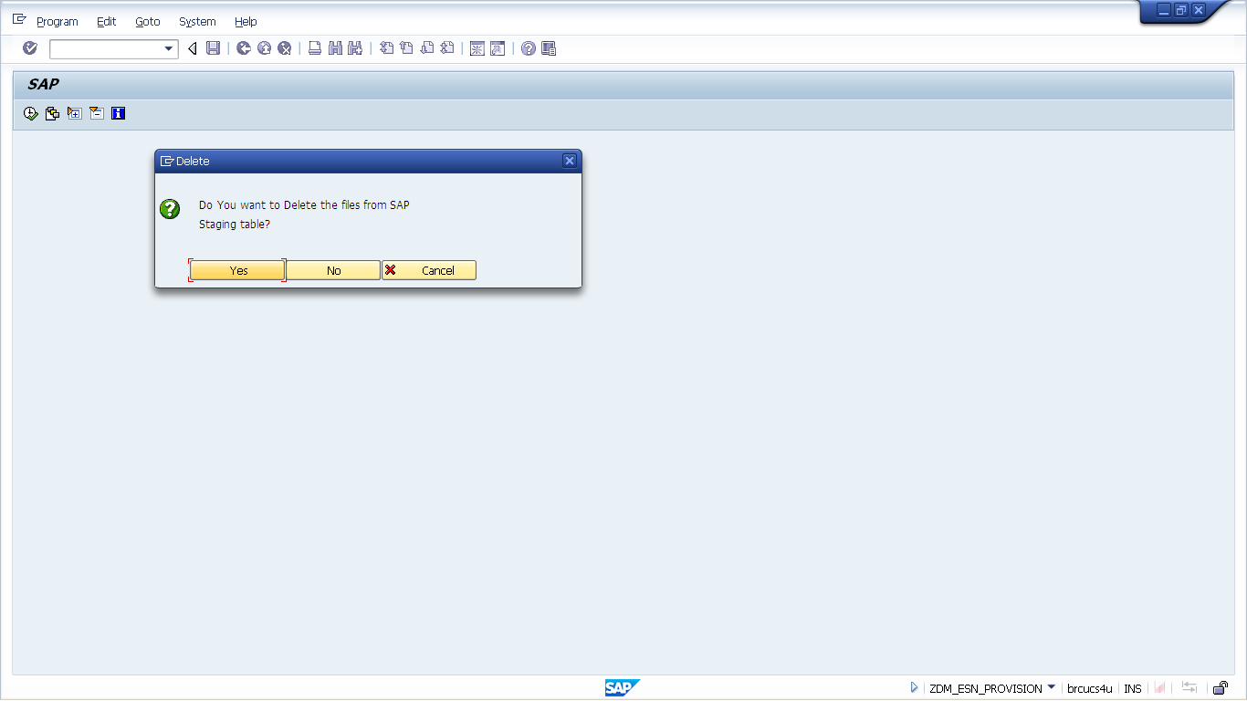
 |  | 3b | MTC | Confirmation of successful deletion is shown
 |  | 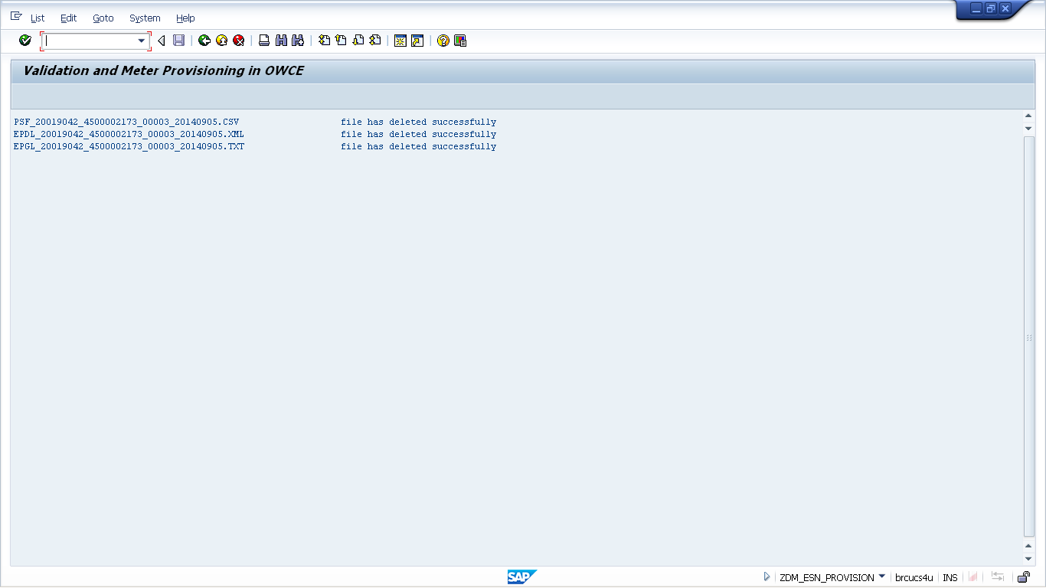

Revision History
Version | Author(s) | Date | Significant Changes
0.1 | Legodile Kwapa | 09/18/14 | Initial Draft

